Case 4-EUR-Greece-Seated Woman-Attic culture- 525–500 BCE

**Greek Terracotta Statuette of a Seated Woman**

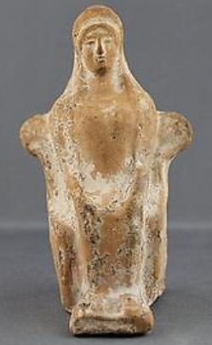

**Greek votive statue in terracotta of a woman seated. Himation around her head, both hands on her knees and feet resting on a footrest. Traces of white slip remaining. Measures 4.9 inches in height and in excellent condition!**

**For a similar item see; The Metropolitan Museum of Art; "Terracotta statuette of a seated woman" Accession Number:59.48.3**

**Value $1500** Galleria Delvecchio Ancient Art [www-galleriadelvecchio-com](http://www.ebay.com/usr/www-galleriadelvecchio-com?_trksid=p2047675.l2559) Oct. 2015